- Factor: 4x + 30y
  - 2(x + 15y)
  - 4(x + 15y)
  - 2(2x + 15y)
  - can’t be factored
- If there are 4x identical schools in a region and each school has 3y classrooms each with 7x desks, how many desks are there in the region?
  - 11x + 3y
  - 28x + 3y
  - 84x$y^{2}$
  - 84$x^{2}$y
- Find the solution for the two following equations by substitution. Express as an ordered pair in the form (x, y).

$$7x-y=22$$
$$4x+2y=10$$
  - (3, -1)
  - (3, 1)
  - (-3, 10)
  - (-3, -1)
- Evaluate the expression 6(x+2) when x = 2.
  - 12
  - 31
  - 13
  - 21
- A minor-league baseball team is giving a local charity the sum of $1500 and $0.50 for each ticket over 2000 sold for one game. Let x represent the number of tickets sold. If the team sells more than 2000 tickets, which of the following expressions could be used to find the amount of the donation?
  - $1500 + $0.50x
  - $1500 + 40.50(2000 – x)
  - $1500 + $0.40(x – 2000)
  - $1500(2000 – x)($0.50)
- Write an expression using x the following description: the product of 8 and a number is decreased by 10.
  - 8(x - 10)
  - 8x - 10x
  - 8 - 10x
  - 8x - 10
- What is the sum of the exponents in the expression $4x^{3}+3x^{2}+5$.
  - 3
  - 5
  - 12
  - 17
- Simplify: $\frac{4x^{2}\left(x+y\right)-2(x+y)^{2}\left(x-y\right)-xy(x+y)}{x+y}$.
  - 2$x^{2}+2y^{2}-xy$
  - 4$x^{2}+xy-2x-2y$
  - 4$x^{2}-xy-2x-2y$
  - 2$3+2xy^{2}-xy$
- A charity with a yearly budget of 80d gets all of its money from either its yearly ball or from private donations. If the charity raised 64d from the silent auction at the ball and 4a from ticket sales at the ball, how much will need to be raised in private donations to meet the budget.
  - 16d
  - 16d - 4a
  - 16d + 4a
  - 144d – 4a
- If the 3h people in one country and the 4k people in the neighboring country each consume h – 17 pounds of rice per year on average, how many pounds of rice would be consumed by both countries in one year?
  - 4h + 4k – 17
  - 4$h^{2}$ + 4k – 68k
  - 12hk + h – 17
  - 3$h^{2}$ - 4hk – 51h – 68k
- Simplify the expression $\frac{(a-{4)}^{2 }(6b)}{2\left(3b\right)\left(a+4\right)(a-4)}$ .
  - $\frac{a-4}{a+4}$
  - $\frac{a+4}{a-4}$
  - $\frac{a-2}{2}$
  - 1
- Which of the following expressions is equal to $\frac{2z^{2}-12z+2\left(z+4\right)-4}{2z}$ .
  - z-5
  - z(z + 2) – 5
  - z(z + 2) – 5(z + 2)
  - z – 3
- What is the value of the expression $\frac{4^{3}-[3\left(12+2^{2}\right)]}{ 6+5\left(4\right)-15}$ ?
  - 1$\frac{5}{11}$
  - 2
  - 3 $\frac{7}{9}$
  - 2.5
- Emilie buys x ounces of chicken for each of her guests at a dinner party. There are 8y people coming, and chicken is $z a pound. How much will the total amount of chicken cost in dollars? (Hint: there are 16 ounces in one pound.)
  - 8xyz
  - 16xyz
  - $\frac{xyz}{2}$
  - $\frac{xyz}{8}$
- Solve: -2a – 8 = -4
  - a = -2
  - a = 2
  - a = 4
  - a = -4
- Solve $\frac{3}{7}+x= \frac{17}{7}$
  - x = 2
  - x = -2
  - x = 3
  - x = -3
- A cab company does not charge a boarding fee, but then has a meter of $4 an hour. What equation represents the company’s rate?
  - y = 4x
  - x = 4y
  - y = 4 + x
  - y = 4 – x
- Your yard is a mess, and you decide to hire a landscaper. The Garden Pros charges a $50 consultation fee plus $36 per hour for the actual work. If the total cost is $212, how many hours did the landscapers work?
  - 4 hours
  - 4.5 hours
  - 3.52 hours
  - 7.28 hours
- Three added to the product of -4 and a number (x) is less than 5 added to the product of -3 and the number. Which of the following is a graph of the solution set of x?
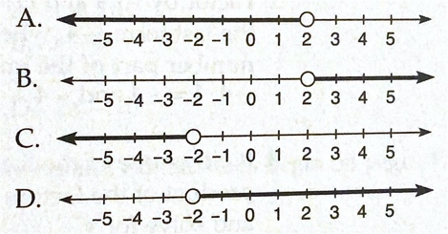

- Which of the following graphs represents the solution set of the inequality -2(x-6) > 8?
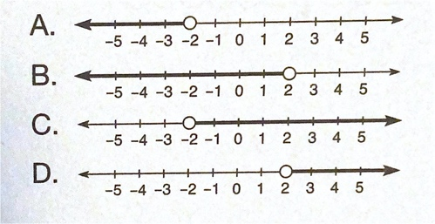

- Jason is buying wings and hot dogs for a party. One package of wings costs $7. Hot dogs cost $2 per pound. He must spend less than $40 and he wants at least 4 pounds of hot dogs and 2 packages of wings. Write an inequality for the situation.
  - 7x + 2y $≤$ 40
  - 7x + 2y $≥$ 40
  - 7x + 2y $>$ 40
  - 7x + 2y $<$ 40
- Samuel is paid $350 per month plus a 10 percent commission on his total sales for the month. If he needs to earn at least $2100 per month, which of the following expressions represents thte total sales for the month (s) Samuel needs to achieve?
  - $s≥\$17,500$
  - $s≤\$17,500$
  - $s≥\$21,000$
  - $s≤\$21,000$
- Solve $a^{2}+2a-24=0$.
  - a = -6, 4
  - a = 6, -4
  - a = 12, -2
  - a = 8, -3
- For which of the following equations is x = -4 a solution?
  - ${2x}^{2}-8=0$
  - $x^{2}-8x+64=0$
  - $x^{2}-2x-15=0$
  - ${2x}^{2}+2x-24=0$
- Lainey and Cam had 100 playing cards. Both of them lost 20 cards each. The product of the cards they now have is 900. Let A be the number of playing cards Cam started with. Which of the following quadratic equations does A satisfy?
  - $A^{2}+100A+2500= 0$
  - $A^{2}+100A-2500= 0$
  - $A^{2}-100A+2500= 0$
  - $A^{2}-100A-2500= 0$
- The product of two consecutive integers is 306. Let the smaller integer be N. Which of the following quadratic equations does N satisfy?
  - $N^{2}-N+306=0$
  - $N^{2}+N+306=0$
  - $N^{2}+N-306=0$
  - $N^{2}-N-306=0$

