- Two of the corners of a triangle are located at (3, -3) and (2, 3). What is the location of the third corner as shown in the diagram below?
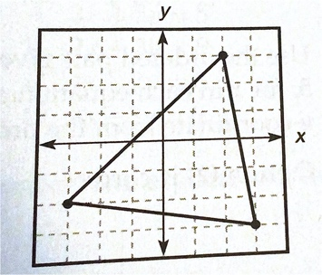

  - (-3, -2)
  - (-3, 2)
  - (-2, -2)
  - (3, -2)
- Which of the following ordered pairs shows the location of point L?
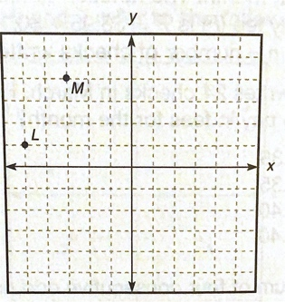

  - (-5, -1)
  - (-5, 1)
  - (-1, 5)
  - (1, -5)

Questions 3 and 4 refer to the following graph.
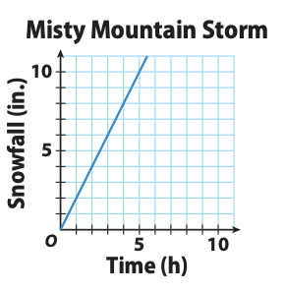

- What is the unit rate of snowfall in inches per hour?
  - 2 inches/hour
  - 3 inches/hour
  - 1 inch/2 hour
  - 5 inches/9 hour
- Which point on the graph tells you the slope of the graph and the unit rate of change in the snow level?
  - (5, 10)
  - (2, 1)
  - (0, 0)
  - (1, 2)
Questions 5 and 6 refer to the following graph.
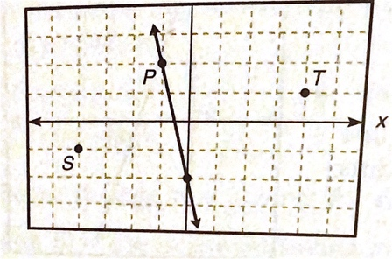

- The graph of the equation $y=\frac{1}{4}x$ will pass through which of the following pairs of points?
  - Point S and (-1, 2)
  - Point S and (0, -2)
  - Point T and (0, 0)
  - Point T and (0, -2)
- Line P is the graph of which of the following equations?
  - y = 4x + 1
  - y = -4x -1
  - y = 4x + 2
  - y = -4x – 2
- What is the equation of a line with a slope of -4 that passes through the point (1, 2)?
  - y = -4x +2
  - y = -4x + 6
  - y = 4x + 1
  - y = 4x + 6
- Which of the following equations describes the same line as y – 2 = $\frac{1}{2}$ (x – 6)?
  - y = 3x + 2
  - y = $\frac{1}{2}$x – 4
  - y = -x + 12
  - y = $\frac{1}{2}$x – 1
- Which of the following is an equation for the line that passes through (-1, 0) and (2, -3)?
  - y = 3x + 3
  - y = -3x + 9
  - y = -x – 1
  - y = x – 5
- Which of the following is an equation for the line that passes through (-3, 4) and (1, 4)?
  - y = 0
  - y = 4
  - y = x + 3
  - y = x+ 7
- Find the slope of a line parallel to the line y = -7 + 5.
  - 7
  - -7
  - 5
  - 5/7
- Find the slope of the line perpendicular to the line $-\frac{3}{2}$x + y = 0.
  - $-\frac{3}{2}$
  - $-\frac{2}{3}$
  - $\frac{3}{2}$
  - $\frac{2}{3}$
- Carla’s daughter is participating in a summer reading program at the library. She is reading two books a week. Which of the following functions expresses her summer reading, where w is the number of weeks in the program?
  - f(w) = w + 2
  - f(w) = 2w
  - f(w) = 2b
  - 2f(w) = w
- Bryan is on a road trip with his best friend, and they like to get up early. Each day, they drive 100 miles before breakfast, and then they drive an average of 60 miles per hour for each hour they are on the road until they stop for the day. They never spend more than 8 hours on the road after breakfast. If h is the number of hours they drive after breakfast, which of the following are the domain and range of the function that represents their daily driving?
  - Domain is $0≤h≤8$; range is $100≤f(h)≤580$.
  - Domain is 10$0≤h≤580$; range is $100≤f(h)≤8$.
  - Domain is $h≥0$; range is $f(h)≥100$.
  - Domain is $h≤8$; range is $60≤f(h)≤100$.

