- Order from least to greatest: 0.62, 0.5, 0.57
  - 0.62, 0.5, 0.57
  - 0.57, 0.62, 0.5
  - 0.5, 0.62, 0.57
  - 0.5, 0.57, 0.62
- In the number line below, what is the value of A – B?

  - 1
  - 1 ½
  - 2
  - 3 ½

Question 3 is based on the following information.

- Which of the following shows the drill bits arranged in order from least to greatest in size?
  - Cutter, bevel, classic, core box
  - Core box, bevel, classic
  - Bevel, classic, cutter, core box
  - Core box, classic, bevel, cutter
- What is the GCF of 24 and 16?
  - 8
  - 4
  - 6
  - 2
- Which of the following is equal to 6-4(x+3)?
  - 4x+3
  - 4x-9
  - -4x+9
  - -4x-6
- Solve: 30 + 75 =
  - 5(3+7)
  - 10(6+5)
  - 15(2+5)
  - 150(5+2)
- Absolute error is the absolute value of the difference between an actual value and its measurement. A deli scale gives a measurement of 25 ounces for a cut of meat that actually weighs only 23.5 ounces. What is the absolute error, in ounces, of the deli scale in this instance?
  - 1.5
  - 23.5
  - 25
  - 48.5
- Use absolute value to find the solution: |-6|-|-7|
  - -1
  - 1
  - 42
  - 2
- What is the absolute value of |-125|?
  - |125|
  - |-125|
  - 125
  - -125
- Which of the following is equivalent to x² -25?
  - x(x-25)
  - (x-5)²
  - (x+5)(x+5)
  - (x-25)²
- The cube pictured below measures 6 inches on each side. You can find the volume of the cube by multiplying length x width x height. Which of the following expressions represents the volume of the cube, in cubic inches?
  - 6¹
  - 6²
  - 6³
  - 6⁶
- Multiply 7c²(a²+5b+7c²)
  - 7a²c² + 35bc² + 49c⁴
  - 7(ac)² + 35(bc)² +49c⁴
  - 7a² + 35b + 49c⁴
  - a2+5b+14c
- What values would make the expression $\frac{70v^{2}}{100v}$ undefined?
  - 100
  - $\frac{1}{100}$
  - -100
  - 0
- For what values of a is the expression $\frac{a(4a-16a)}{a x \left|a\right|+ a^{2}}$ undefined?
  - a = 4
  - a $≤$ 0
  - a = 16
  - a $≥$ 0
- What values would make the expression $\frac{m+7}{m^{2}+4m-21}$ undefined?
  - 7 and -3
  - 7 and 3
  - -7 and 3
  - -7 and -3
Question 16 refers to the following graph.
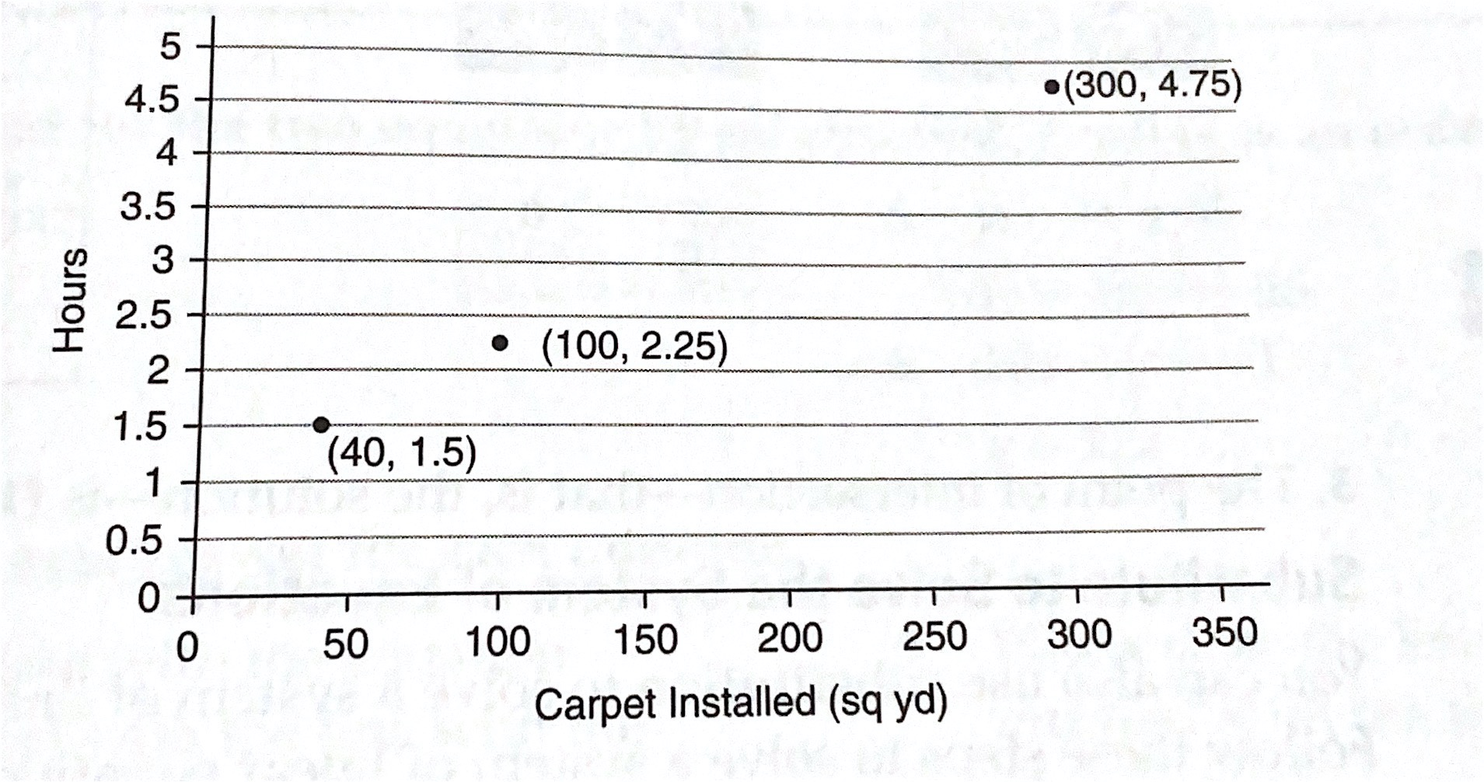
- On three carpet installation jobs, a contractor records the values above with the goal of analyzing whether her rates are high enough given the time it takes her to install carpet. It takes her 1 hour to collect tools and drive to a worksite. The x-axis shows square yards of carpet, and the y-axis shows hours spent. What is her rate of time per area installed?
  - 0.0125 hr per sq yd
  - 0.01625 hr per sq yd
  - 0.0375 hr per sq yd
  - 80 hr per sq yd
- If the bakers at Mountain Bakery make 228 loaves of bread in 4 hours, what is the rate per hour?
  - 54
  - 56
  - 57
  - 58
- What is the scale factor of this image?
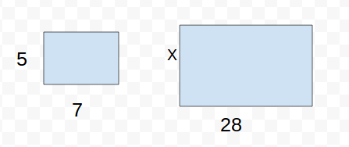

  - 5
  - 4
  - .25
  - 6
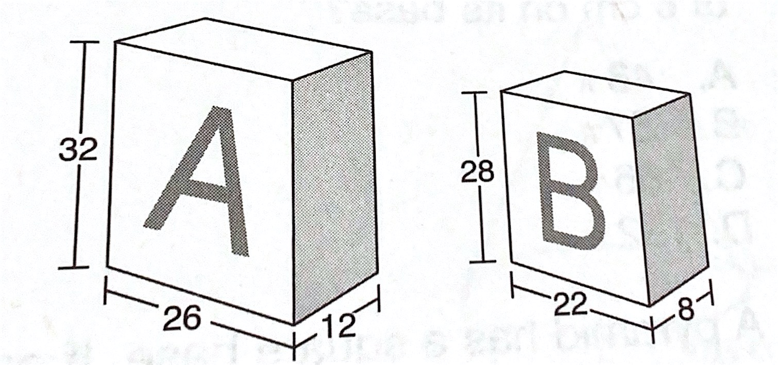
- Based on the drawing below, how many cubic centimeters greater is the volume of Box A than the volume of Box B?

  - 64
  - 1,448
  - 4,928
  - 5,056
- A team played 77 games and won 56 of them. There were no tied games. What is the ratio of wins to losses?
  - 3:8
  - 8:11
  - 11:8
  - 8:3
- A local hospital currently has 184 male patients. If the ratio of male to female patients is 4:3, how many female patients are there in the hospital?
  - 4
  - 138
  - 245
  - 185
- David bought a computer game on sale for $36. The game was originally $48. What was the percent of decrease in the game’s price?
  - 12%
  - 25%
  - 33 $\frac{1}{3}$%
  - 75%
- At a restaurant, Pat’s total bill is $46. If he wants to tip 15 percent, how much should he leave as a tip?
  - $690.00
  - $31.00
  - $15.00
  - $6.90

