- Find the area of the figure below.
4

4 4

4
- 16 sq units
- 24 sq units
- 12 sq units
- 20 sq units

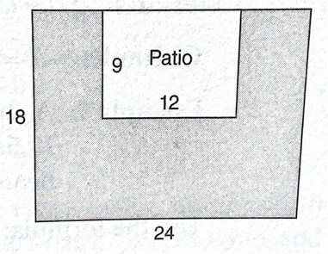
- Martin is building a rectangular patio centered on one side of his yard. The rest of his yard, shown in the diagram, is planted in grass. If the measurements in the diagram are in feet, what is the square footage of the grass portion of Martin’s yard?

  - 108
  - 162
  - 324
  - 432
- The area of a triangle is 24 sq. inches. If the base of the triangle is 6 inches, what is its height?
  - 6 in
  - 8 in
  - 9 in
  - 12 in
- The perimeter of an equilateral triangle is 27 centimeters. What is the length of the side?
  - 8 cm
  - 9 cm
  - 12 cm
  - 27 cm
- Find the circumference of the following circle. Take $π$ = 3.14.
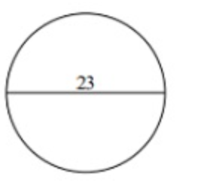

  - 18.84 units
  - 47.3 units
  - 72.22 units
  - 47.1 units
- On the target below, the 5- and 10-point bands are each 2 inches wide, and the 25-point inner circle has a diameter of 2 inches. (Note: figure not drawn to scale.)
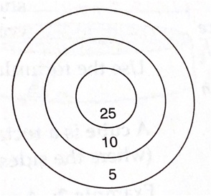

To the nearest inch, what is the outer circumference of the 10-point band?
  - 6
  - 13
  - 19
  - 113
- What is the perimeter of the figure below?
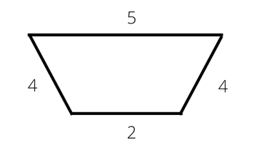

  - 15
  - 10
  - 8
  - 22
- If the perimeter of a regular hexagon is 30 inches, what must be the length of each side?
  - 6 in
  - 7 in
  - 5 in
  - 4 in
- The area of a trapezoid is 1900 units. If one of the parallel sides is 50 units and its height is 50 units, what is the length of the other parallel side? (Note: Drawing not to scale)
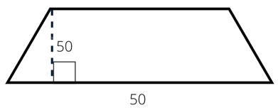

  - 26 units
  - 18 units
  - 50 units
  - 30 units
- The hypotenuse of a right triangle measures 39 inches. If one leg measures 15 inches, what is the measure of the other leg, in inches?
  - 36
  - 24
  - 18
  - 12
- In a right triangle, the hypotenuse measures 15 inches. If one leg of the triangle measures 6 inches, which of the following equations could be used to find the length of the other leg (x) in inches?
  - $x=\sqrt{15-6}$
  - x = 15 – 6
  - $x^{2}={15}^{2}+ 6^{2}$
  - $x^{2}={15}^{2}- 6^{2}$

- If the dimensions of the box below are doubled, by how many square centimeters does the surface area increase?
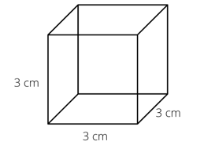

  - 8
  - 54
  - 162
  - 216
- Find the volume of the object below to the nearest whole unit.
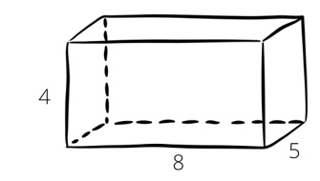

  - 160 cubic units
  - 150 cubic units
  - 184 cubic units
  - 200 cubic units
- All the edges of a metal box are of equal length. If the surface area is 150 square inches, what is the length, in inches, of each edge of the box?
  - 5
  - 6
  - 25
  - 50
- The rectangular box below with a volume of 80 cubic feet has the length and width shown in the drawing. What is the height, in feet, of the box?
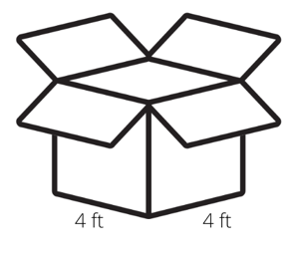

  - 5
  - 10
  - 16
  - 20

- Linda adds a water stabilizer to her children’s swimming pool once a week. The instructions tell her to add one scoop of the product for every 20 cubic feet of water. About how many scoops should she add per week?

  - 3
  - 6
  - 17
  - 36
- In the cylinder below, the diameter of the circular base is equal to the height of the cylinder. What is the surface area of the cylinder, to the nearest square inch?
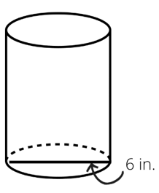

  - 57
  - 113
  - 170
  - 339
- A cylinder with a radius of 2 inches has a volume of 125.6 cubic inches. What is the height of the cylinder?
  - 10 inches
  - 12 inches
  - 14 inches
  - 16 inches
- What is the volume of this rectangular prism?
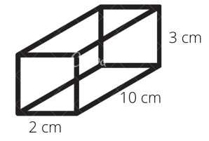

  - 20 cubic centimeters
  - 50 cubic centimeters
  - 60 cubic centimeters
  - 90 cubic centimeters
- Which of the following is a true statement about the figures shown below? (Measurements indicated are all in the same units. Note that the figures are not drawn to scale.)
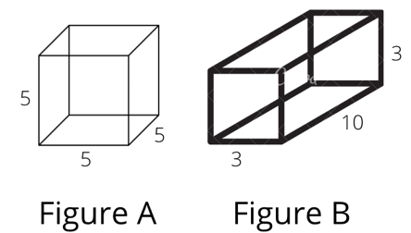

  - The surface area of Figure A is equal to the surface area of Figure B.
  - The surface area of Figure A is half of the surface area of Figure B.
  - The surface area of Figure A is greater than the surface area of Figure B.
  - The sum of the surface areas of both Figure A and Figure B is greater than 300.

- What is the volume of the cone shown below?
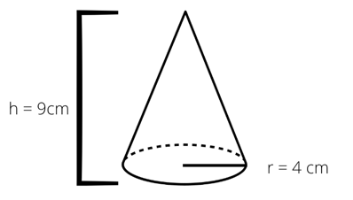

  - 150.79 cubic centimeters
  - 75.36 cubic centimeters
  - 452.16 cubic centimeters
  - 152 cubic centimeters

Question 22 refers to the following figure.
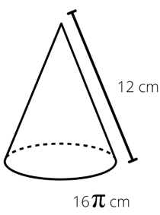

- Sarah is making party hats for a birthday party. Each hat is in the shape of a cone and will have a circumference of 16 $π$ cm and a slant height of 7 cm. She will be making 20 hats. What is the total surface area, in square centimeters, of all 20 hats combined?
  - 54 $π$
  - 96 $π$
  - 192 $π$
  - 1,920 $π$
- If the length of the diameter of a sphere is 8, how many square units is its surface area?
  - 16 $π$
  - 64 $π$
  - 256 $π$
  - 512 $π$
- What is the height of a cone with a radius of 3 units and a volume of 50 cubic units?
  - 5.305 units
  - 6.72 units
  - 12 units
  - 15 units
- The volume of a basketball is 36 $π$ units. What is its diameter?
  - 7 units
  - 6 units
  - 8 units Year
  - 9 units

Question 26 refers to the following graph.

- By about what percent did orders at National Aircraft decrease from 2008 to 2009?
  - 30%
  - 40%
  - 68%
  - 75%

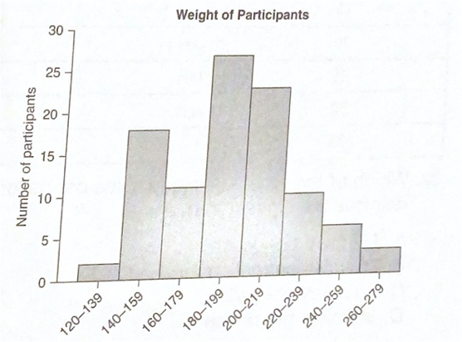
- A hundred people are participating in a medical study. As a first step, the researchers collected information about participants’ weight. The graph below represents how many people fell into each weight category. Which weight category displays the highest frequency?

  - 120-139 lbs
  - 180-199 lbs
  - 200-219 lbs
  - 260-279 lbs

- The following dot plot shows the number of hours per week that these 25 students reported spending on homework. What percentage of the students reported spending 4 or fewer hours on homework each week?
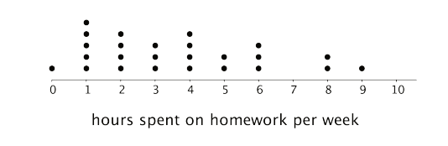

  - 20%
  - 40%
  - 68%
  - 72%
- Influenza, or “flue,” season in the United States tends to last from fall through spring. Approximately what percentage of flu cases was reported to the CDC during the 2012-2013 season during the time period of December 9 to January 5?

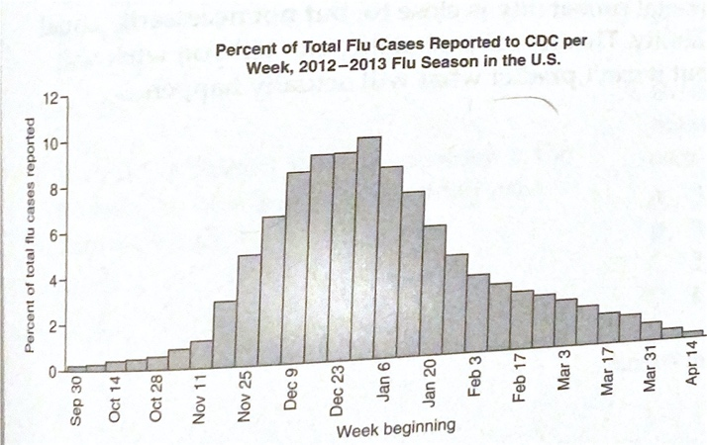

  - 7%
  - 15%
  - 36%
  - 50%

- Over what period of time did the price of goods actually decrease?
  - 1930 to 1940
  - 1940 to 1950
  - 1960 to 1970
  - 1970 to 1980

Questions 30 and 31 refer to the graph below.
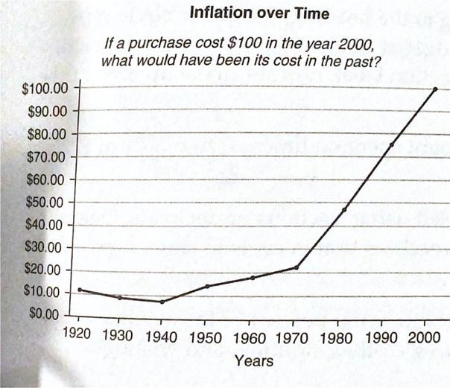

- Goods purchased in 1970 were about what fraction of their cost in the year 2000?
  - $\frac{4}{5}$
  - $\frac{1}{2}$
  - $\frac{1}{3}$
  - $\frac{1}{5}$
Questions 32 and 33 are based on the following table.

Southland Weather March 9

Area | High. Temp | Low Temp. | Precipitation  (in inches)
Downtown | 65°F | 53°F | 0.45
Airport | 62°F | 50°F | 0.63
Woodland Hills | 68°F | 50°F | 1.34
East Village | 56°F | 48°F | 3.53
Ventura | 62°F | 49°F | 2.57
Highland Park | 64°F | 55°F | 0.84

- For which area on the table was there the greatest range, or difference between the high and low temperatures?
  - Ventura
  - East Village
  - Woodland Hills
  - Downtown
- Based on the data in the table, what was the median low temperature for March 9?
  - 62.8°
  - 51.5°
  - 50.8°
  - 50°
- A doctor is deciding how to treat a given disease. The doctor will prescribe one medication, one dietary change, and one type of vitamin supplement. There are five medications, five dietary changes, and five types of vitamins the doctor might prescribe. How many combinations are possible?
  - 125
  - 625
  - 1250
  - 3125
- Given six people, how many combinations of three are possible if order does not matter?
  - 20
  - 120
  - 180
  - 720
- Clark’s daughter can also choose the order in which she wants to enjoy the rides. How many possible orderings of three out of the six rides are possible?
  - 18
  - 20
  - 120
  - 720
- Soraya has been given six tasks to do at work, but she has time to complete only four of them. She must decide in what order to do the tasks. How many possible orderings of four tasks are available to Soraya?
  - 24
  - 36
  - 360
  - 720
- What is the probability of drawing a 10 from a standard deck of 52 cards?
  - 1 out of 52
  - 26 out of 52
  - 13 out of 52
  - 4 out of 52
- A coin and a number cube with the numbers 1 through 6 are tossed. What is the probability of the coin showing tails and the number cube showing the number 3?
  - $\frac{1}{12}$
  - $\frac{1}{8}$

  - $\frac{1}{4}$

  - $\frac{1}{2}$

